Project Report

1. INTRODUCTION
   1. Overview

Uber is a transportation company with an app that allows passengers to hail a ride and drivers to charge fares and get paid.

* 1. Purpose

1. The mainis purpose is provide consumers insights on how the number of uber rides changed within different day periode on different in a month in different NYC neighbourhoods.
2. Problem definition and design thinking.

2.PROBLEAM DEFINITION AND DESIGN THINKING

2.1 Empathy MAP

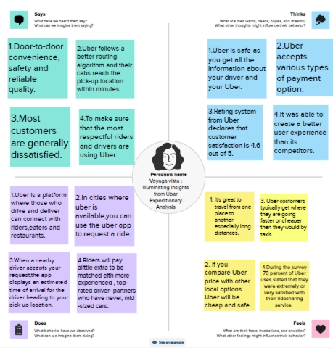

* 1. Ideation and Brainstorming Map

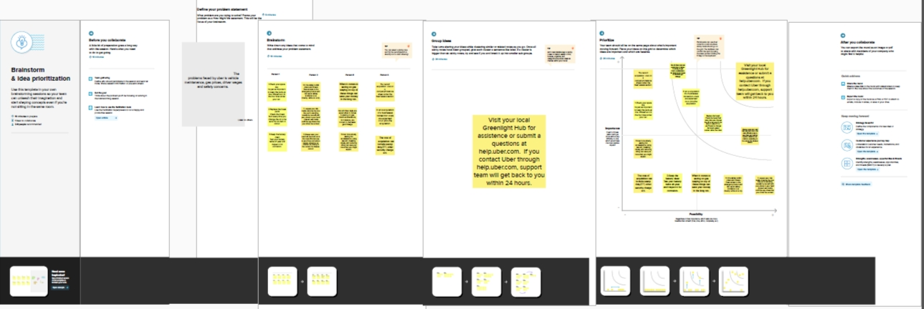

3.RESULT

Ouput of the project

The Screenshot of Dashboard and Story of our project are given below:

Dashboard

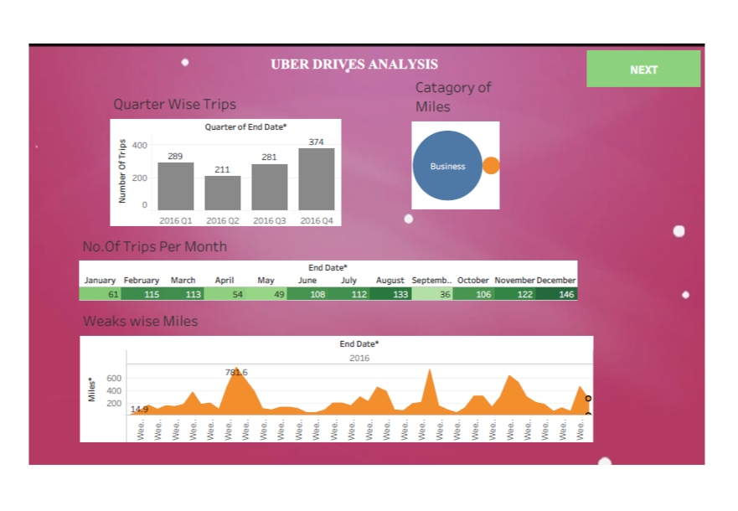

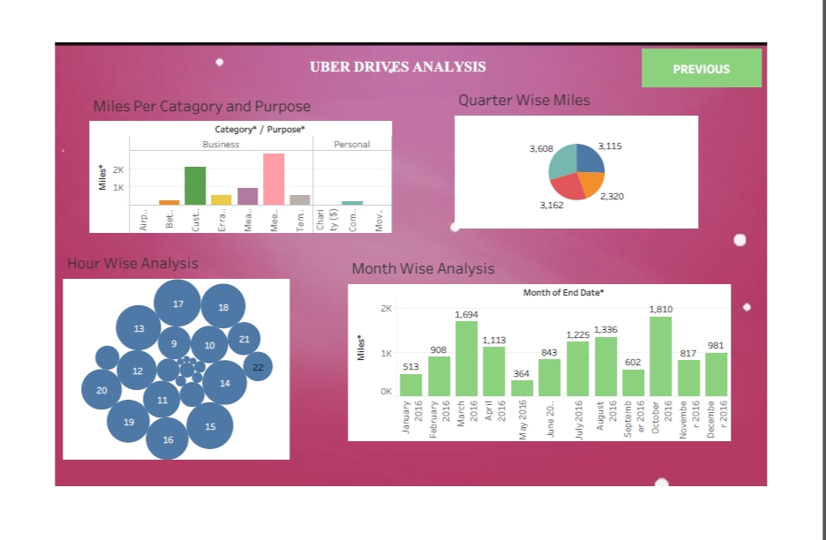

Story

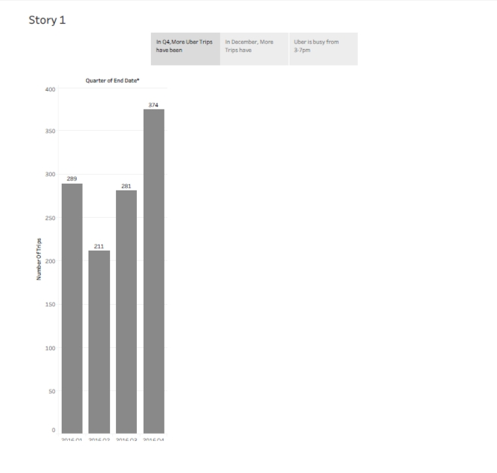

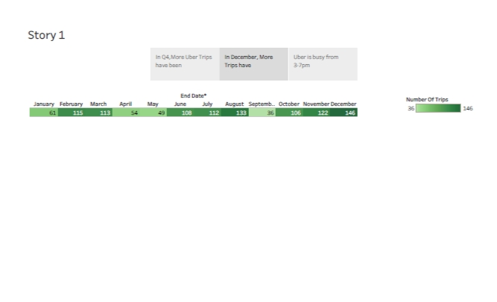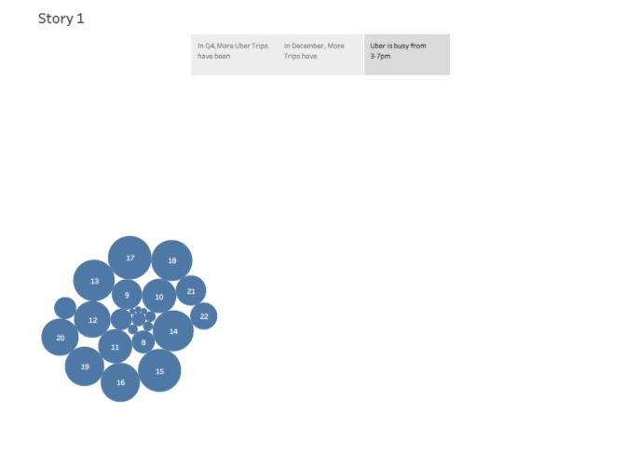4.DISADVANTAGE AND ADVANTAGES:

Advantages:

* Uber could be its avoidance of regulars as suggested by a recent HBR org article.
* Door to Door convenience safety and reliable quality.
* In ubers case both riders and drivers need to be present on the platform in significant numbers.

Disadvantages:

* Its surge pricing and the negative effects of replacing steady jobs with gig work.
* Uber has didrupted taxicab business and allegedly caused an increase in traffic congestion.
* Sometimes due to unavailability of taxi or any other reasons drivers cancel the trip this causes disruptions to a plan of a passenger.

5. APPLICATIONS:

* Uber allows passangers to hail a ride and drivers to charge fares and get paid.
* More specifically uber is riderharing company that hires independent contractors as drivers.
* Uber was started in 2009 by Garrett camp

Travis kalanick , who each invested $200k at the time.

6. CONCLUSION:

The company success can be attributed to several factors, including its innovative business model, user-friendly app and aggressive expansion strategy.

7. FUTURE SCOPE:

It has been observed that the majority of the leading entrepreneurs and startups are ready to start their on demand business with the current frends.